**For the lottery game requirement.**

They need to have few market ( naming will be dynamic value) and all the markets will have the same gameplay in it but just that all these market will have their own unique winning lottery number.

The type of gameplay setting and formula will need to be set inside the system

**4D ( 4 digit)**

4 D number means four digit lottery. Player need to make a winning guess of a 4 winning digit in order to win. This mean for example

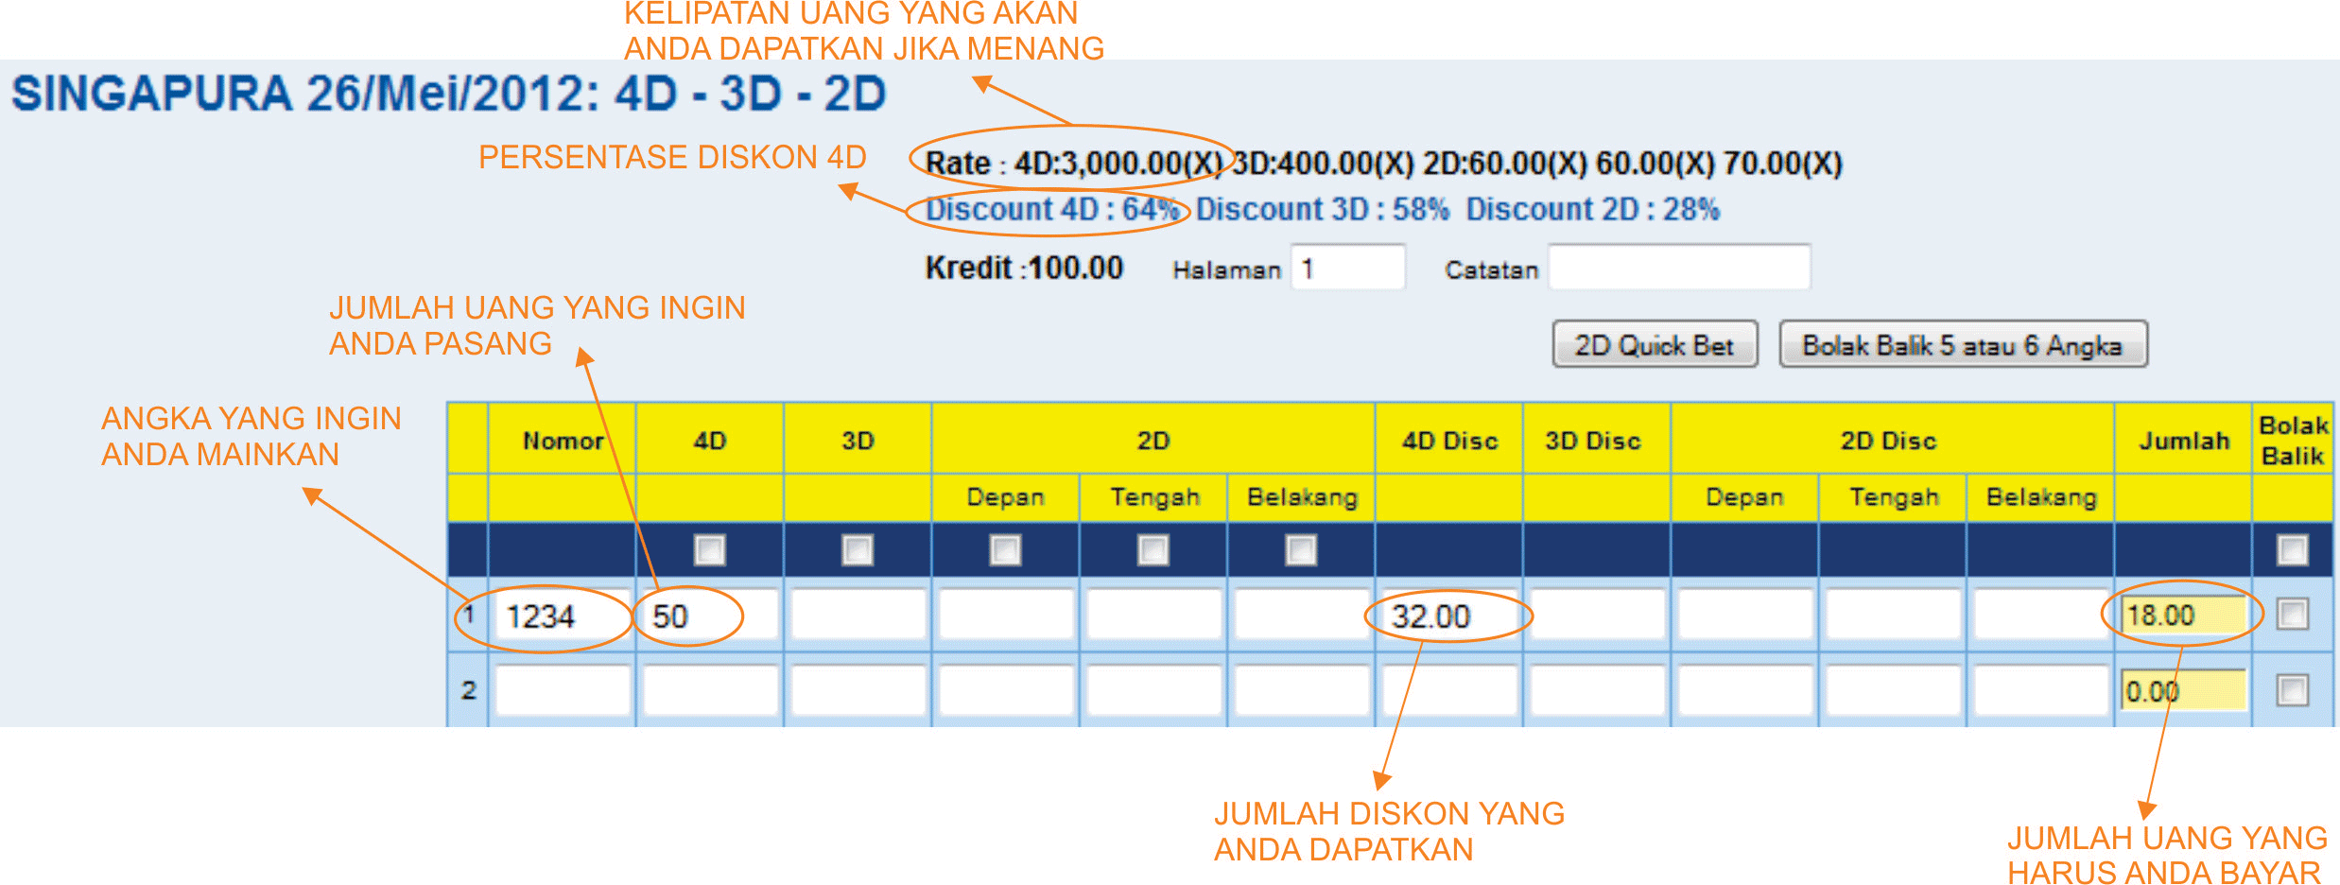

Player buy 1234 for 50 rupiah and since it has 64% discount, so player need only to pay 18 rupiah. And 1234 eventually turn out to be a winning lottery number, he will be eligible for a total payout of 150,000,000 ( 50*3000). If the player lost, he only lost 18

**3D ( 3 digit)**

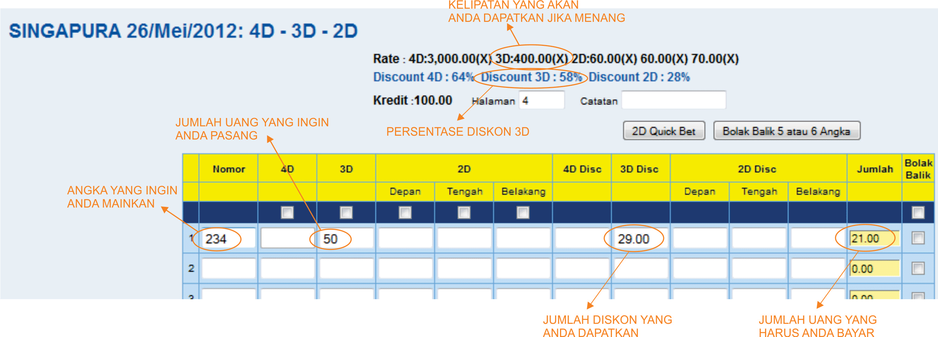

In this case, the discount is 58% so player only need to pay 21 to bet a lottery number of 234, if winning lottery number is 1234, it means he managed to win a payout of 20000000 ( 50*400). If he lost, he only lost 21 rupiah

**2D ( 2 digit)**

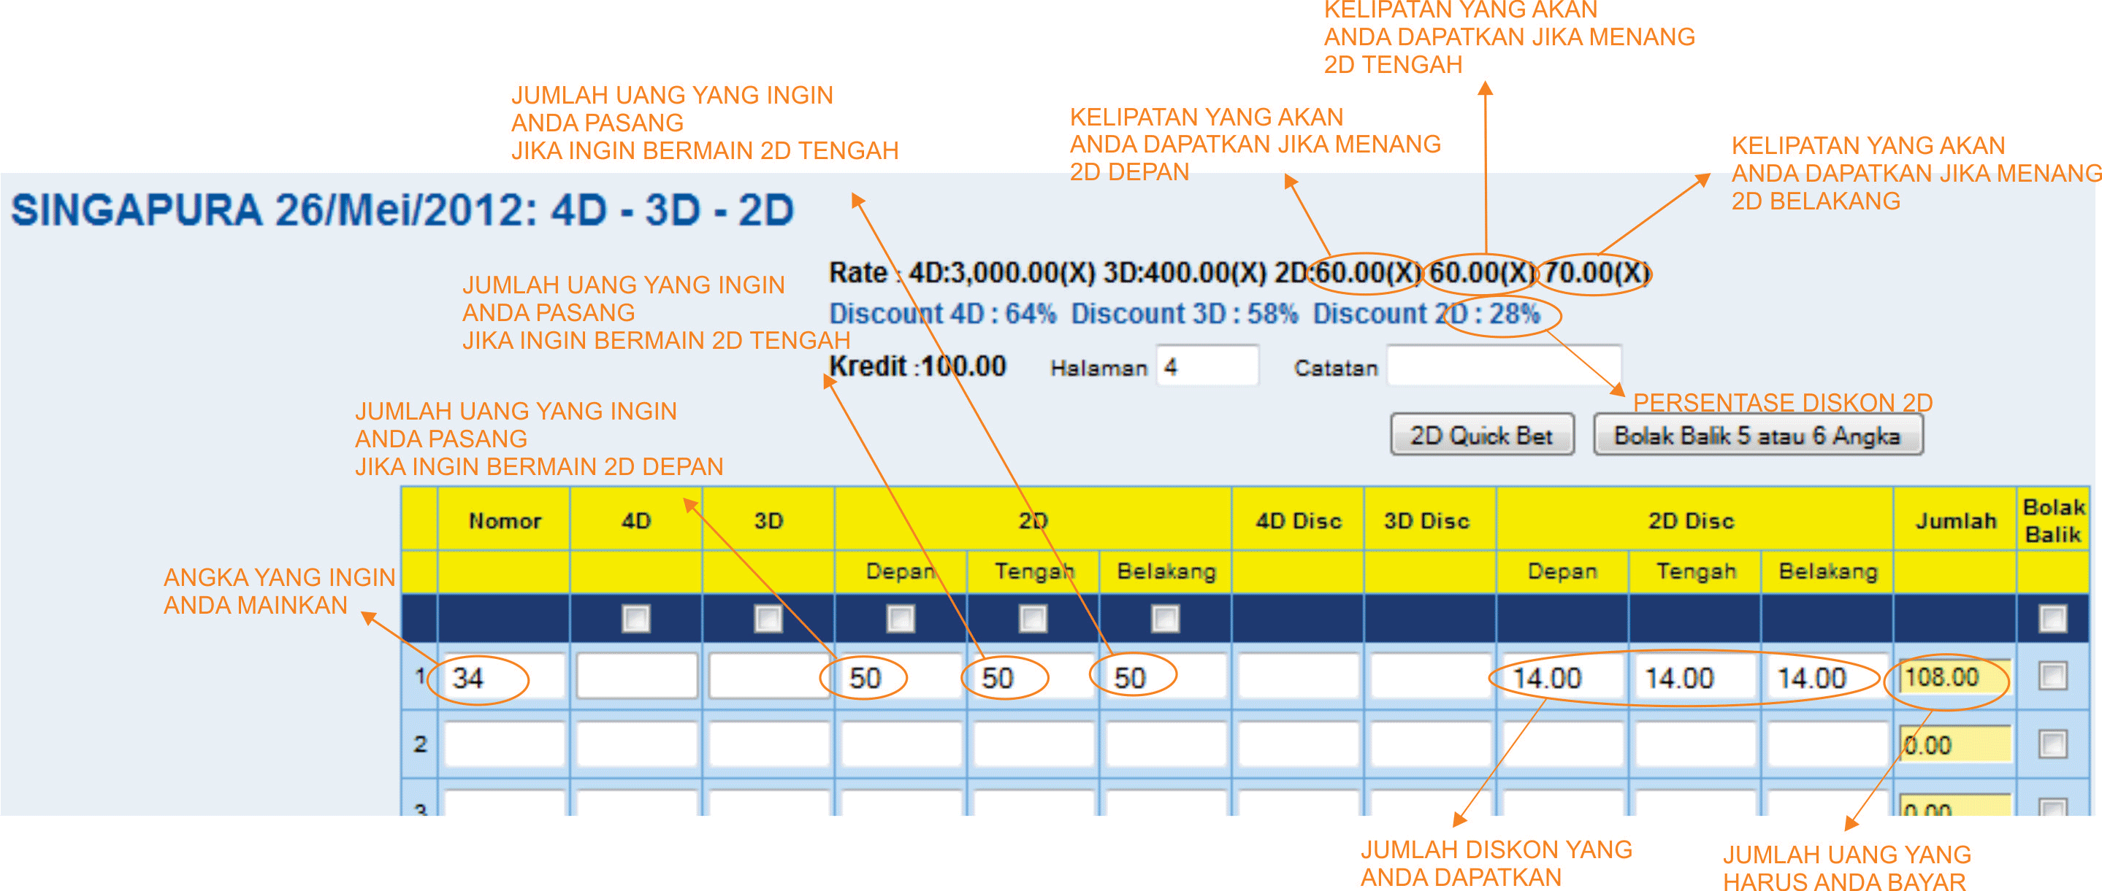

For 2D ( 2 digit) play, they can choose side which is Depan ( front), Tengah ( middle) or Belakang ( behind). Player need to choose whether he want to bet on front, middle or behind portion. In this case he choose 34 for his lottery number. As shown, there can be different winning amount depending on the side player choose. If he choose front he is eligible for 60(x) and if he choose middle , the payout is 60(x) also but if he choose behind, the payout will be 70(x).

So if the winning lottery is 1234 and the player did buy 50 for behind, the payout will be 70(50), which will be 350. Do take note the discount is 28% here.

All the prize rate is dynamic and depending on admin setting. The paying prize for 4d,3d and 2d do not include the original betting amount of the player. This mean that the paying prize will be the betting amount* Prize rate = paying prize. Other type of gameplay will have the betting amount returned to player.

**Colok Bebas ( Freestyle selection**)

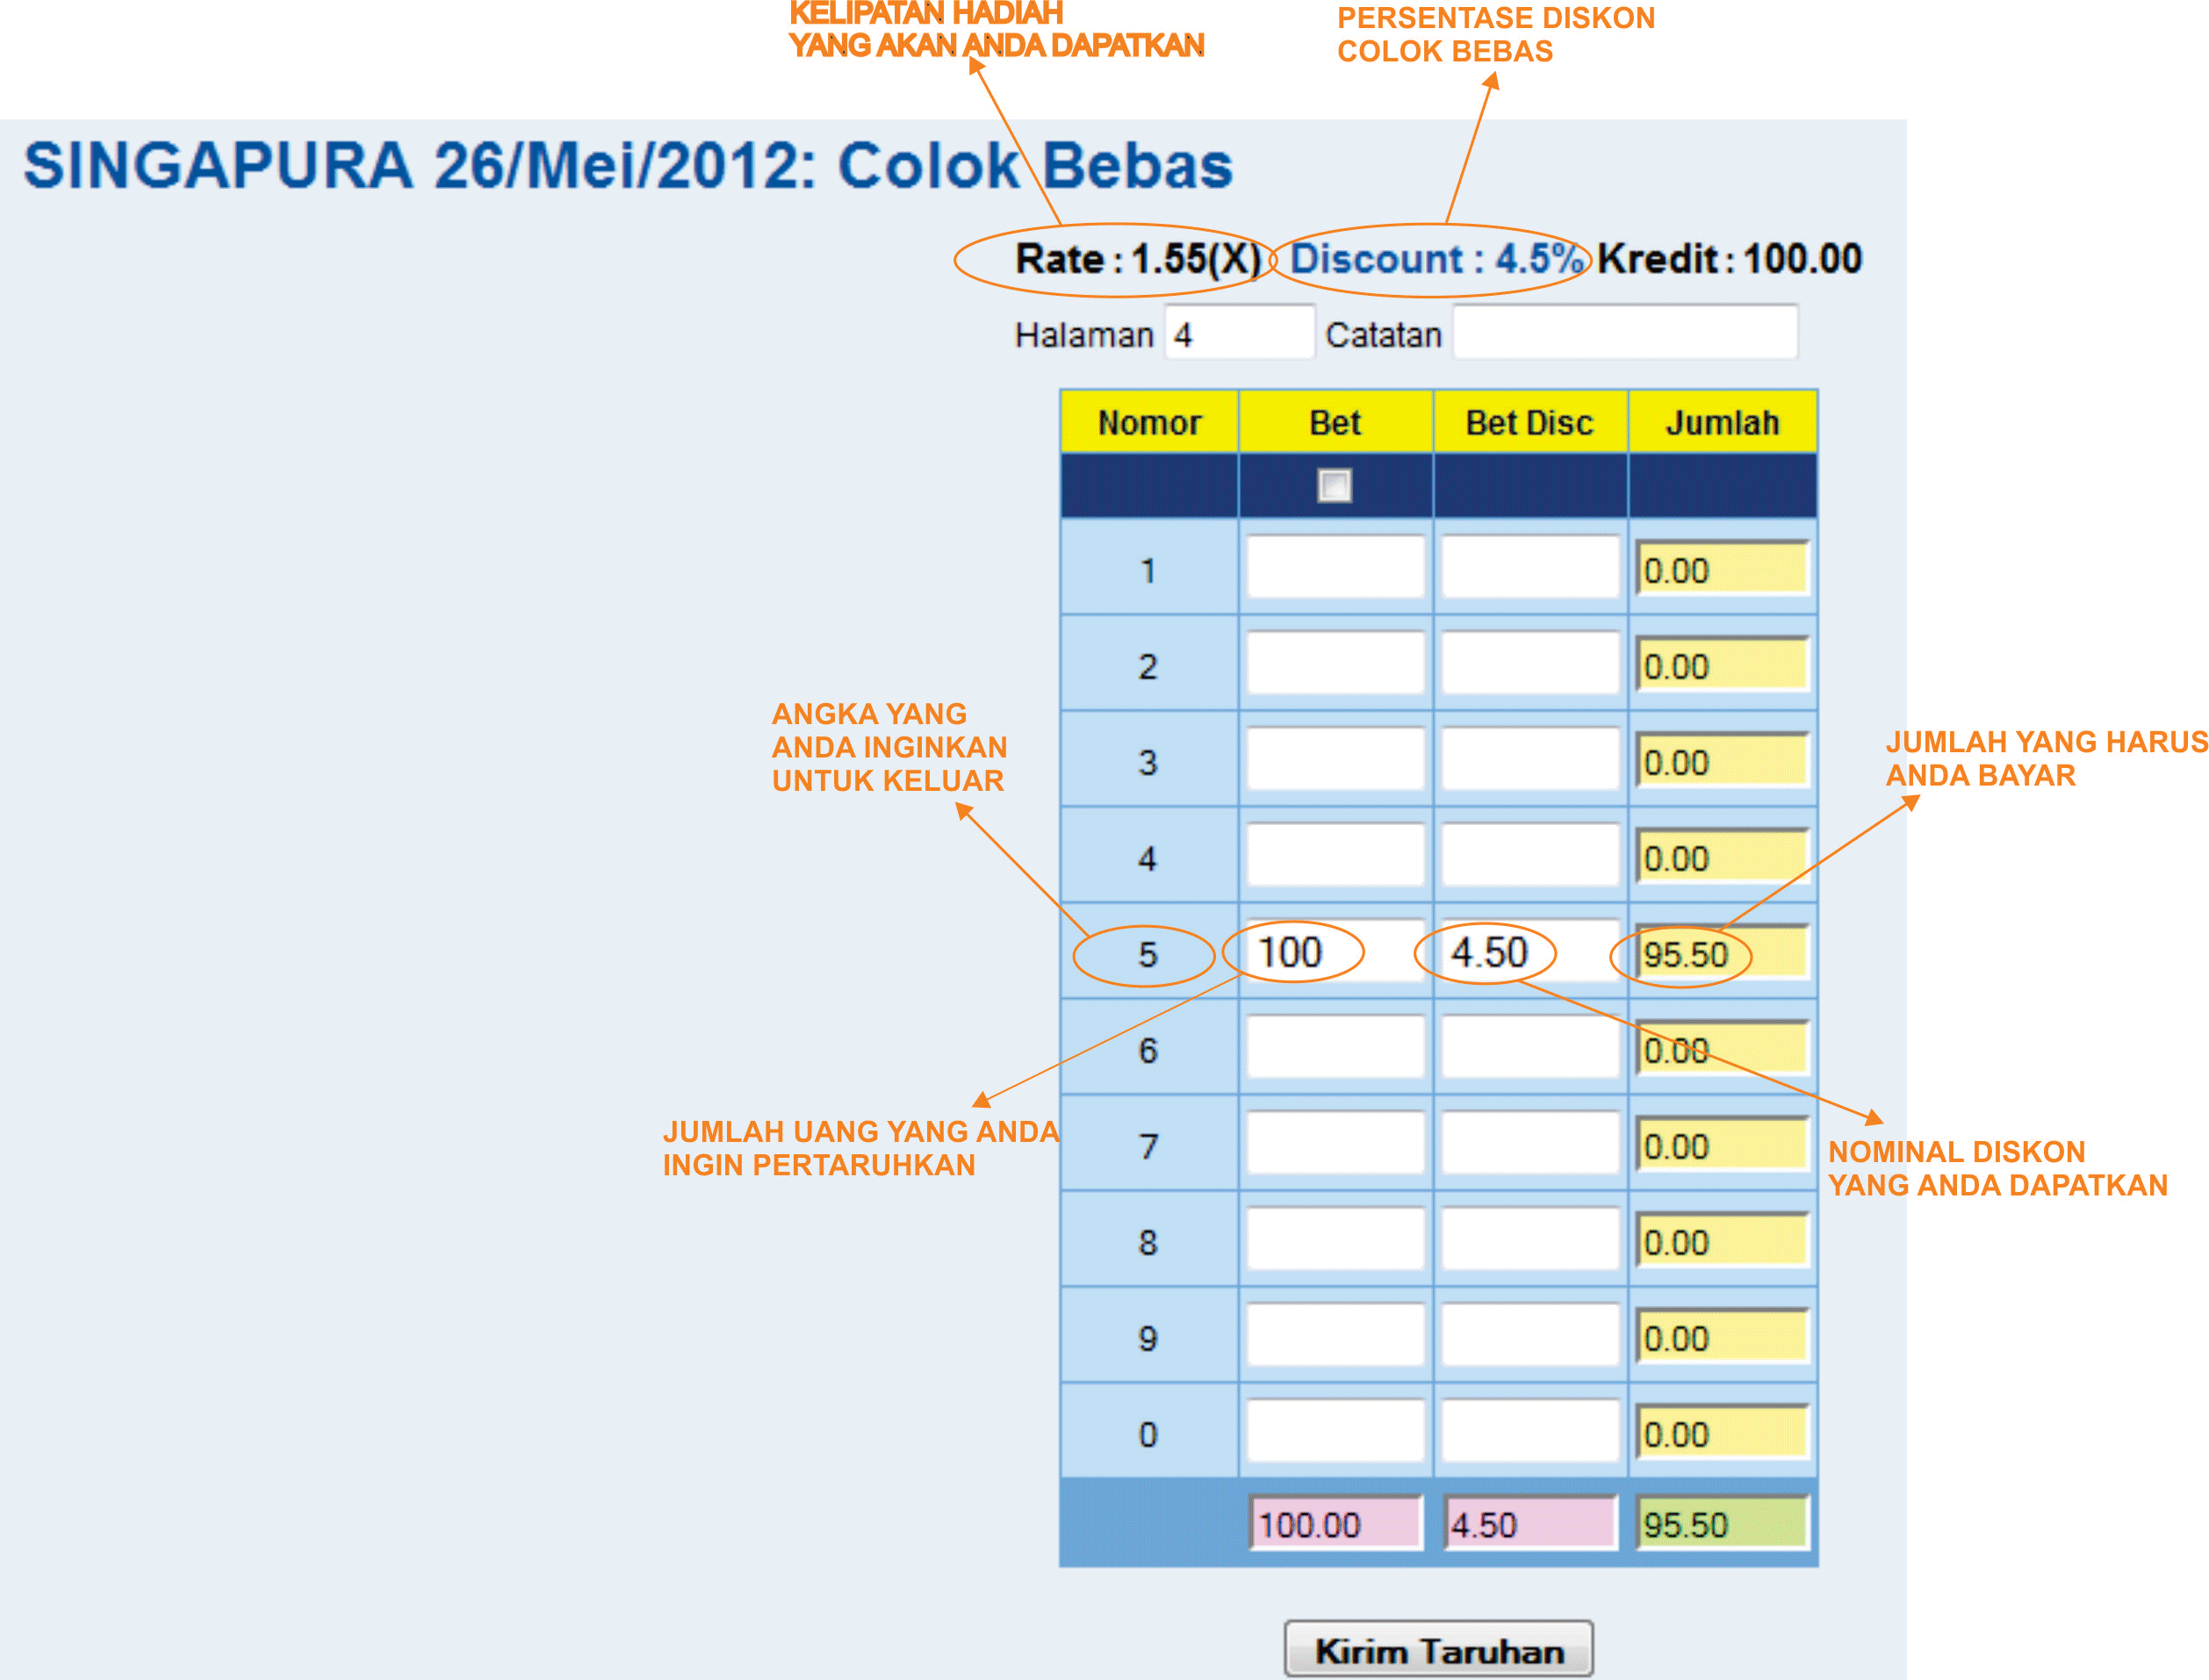

In this case, the prize rate is 1.55 (X) (dynamic value) and the discount is 4.5% ( Dynamic value), so here you can see that digit 5 was chosen as the bought lottery number.

Scenario 1

The winning lottery number is 1334, no digit 5 was found in the lottery number 1334. So player A lost 95.50

Scenario 2

The winning number is 1335, digit 5 was found in the lottery number 1335, so player A won 100+( 1.5*100) which is 255.

Scenario 3

The winning number is 1355, digit 5 was found 2 times in the lottery number 1335, so Player A won 100+(1.5(2) *100 ) which is 400

**Colok bebas 2D /Macau( 2 digit free play)**

It is the same with colok bebas as per above but instead of 1 digit, it need to be 2 digit to appear on the winning lottery in order to win.

Analysis 1

Winning lottery: 4321

Winning rate =10 for normal, 15 for double, 30 for triple ( Dynamic value)

Player A bought 4 and 2 at 100 rupiah

He won since both 4 and 2 are in the winning lottery. So he will win 100 + (10*100)=1100

Analysis 2

Winning lottery: 4321

Winning rate =10 for normal, 15 for double, 30 for triple ( Dynamic value)

Player bought 4 and 6 at 100 rupiah

He lost since only 4 is in the winning lottery and 6 is not there. So the 100 rupiah will be forfeited

Analysis 3

Winning lottery : 4331

Winning rate =10 for normal, 15 for double, 30 for triple ( Dynamic value)

Player bought 4 and 3 at 100 rupiah

He won since both 4 and 3 are in the winning lottery and since 3 appear 2 time, he is eligible for double award, 100+(15*100)=1600

Analysis 4

Winning lottery : 4334

Winning rate =10 for normal, 15 for double, 30 for triple ( Dynamic value)

Player bought 4 and 3 at 100 rupiah

He won since both 4 and 3 are in the winning lottery and since both 4 and 3 appear 2 time, he is eligible for tripple award, 100+(30*100)=3100

**Colok Naga ( 3 digit free play)**

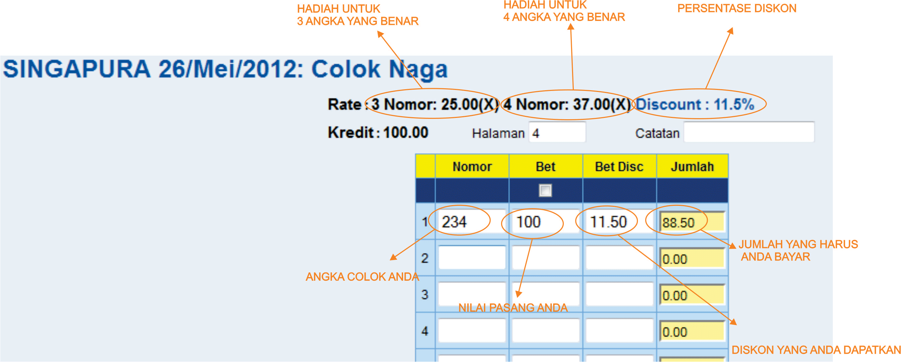

For this, if player manage to hit 3 number regardless of the sequence, they will win the game. As can be seen here, there are probability of winning 3 number or 4 number strike.

Scenario 1

Player bought lottery number 234, and the winning lottery number is 1235 so there are no matching 3 digit there, and the player lost 88.50

Scenario 2

The winning lottery number is 1234, since there are 3 matching digit here, the player won 100+(25*100) which is 2600

Scenario 3

The winning lottery number is 4223, since there are 4 matching digit here, the player won 100+(37*100) which is 3800

**Colok Jitu ( Any 1 number)**

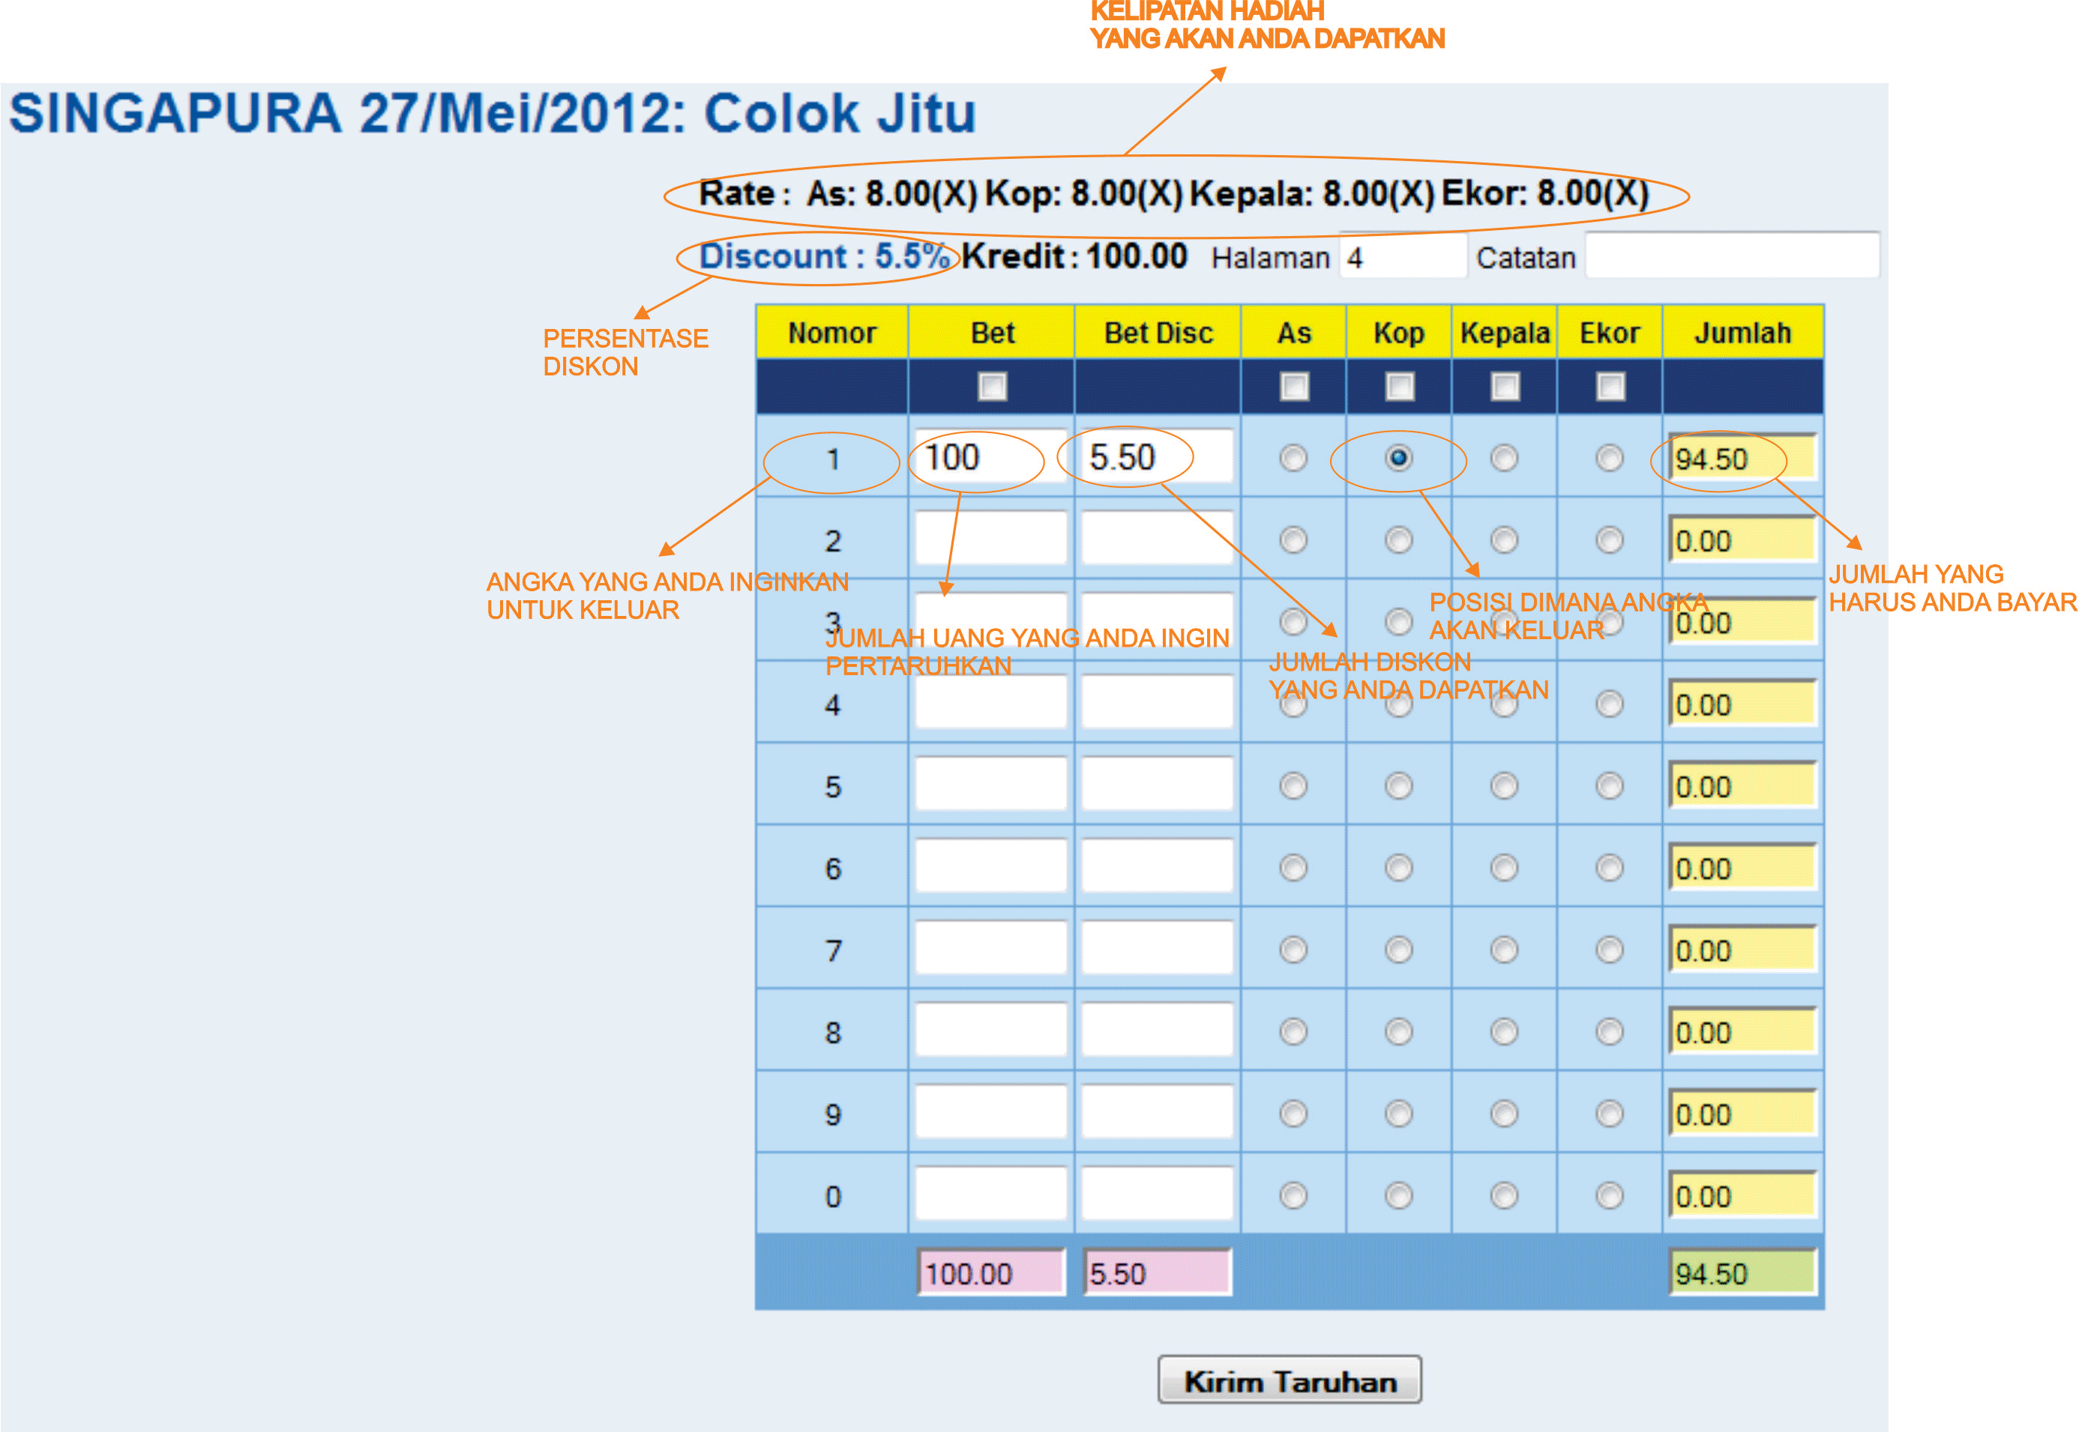

Structure: (AS)(KOP)(Kepala)(Ekor) WXYZ

In the example above, player bet 100 on digit "1" on Kop position and since he has 5.5% discount, he only need to pay 94.5. If the winning lottery number come out is 2132, he will entitled to win 8*100 which will be 800.

If the winning lottery number come out is 1232, he will lose 94.5 since "1" appear on AS position on the winning number, instead of KOP position.

**Tepi Tengah ( Middle/Side)**

Structure of the lottery : ABCD

It is either Tengah/Tepi ( Middle/Side) from a 2 last digit position CD

Tengah( middle) =between 25 to 74

Tepi ( Side)= between 00 to 24 and between 75 to 99

For example:

Analysis 1

Winning lottery number 4321

If buyer buy a Tepi( side), he will strike since the last two digit of the winning lottery number is 21 (CD)

For this, there will be KEI where admin can set +/- to the total buying amount. Let's said buyer A buy at 100 for Tepi and the winning rate is 3 while Kei is +10, so he will need to pay 110 and the prize money for winning is 100+( 100*3) =400. If Kei is -10, he will only pay 90 but the prize money remained the same.

Analysis 2

Winning number is 4356

In this case, if buyer buy Tengah( Middle), he will strike the winning prize since the last 2 digit is 56 (CD) .

KEI will be applicable on here as well.

**Kombinasi(combination)**

Kombinasi ( combination) is a game where odd/even and small/big will be apply

Lottery number structure is ABCD

A=AS, B=KOP, C=kepala and D=EKOR

Big/small: 0-4=small, 5-9=big

Odd/even: 1= odd, 2=even and so-on

Analysis: the winning lottery number is 1845

So in order to win, player need to choose the following:

* AS small/odd and KOP big/even
* Kepala small/even and Ekor big/odd
* AS small/odd and kepala small/even
* AS Small/odd and Ekor Big/odd
* KOP big/even and Kepala small/odd
* KOP big/even and ekor Big/odd

So if the player buy AS small and KOP even at 100, so you will win since the winning number AS is small (1) and the KOP is is even (8). The payout is based on the 100+( rate* 100)

or if the player buy KOP even and kepala even, you will also win since KOP(8) is even and head(4) is even also. The payout is based on the 100+( rate* 100)

But if the player buy Kepala small and Ekor even, he will lose as the Ekor(5) is an odd number. He need to guess the **2** combination correctly in order to qualify for the prize

Do take note that the buying value is effected by KEI and Discount

**DASAR**

Structure: CD ( Last 2 digit)

Small = 0 to 4

Big = 5 to 9

Odd=1,3,5,7,9

Even=0,2,4,6,8

Scenario 1

If winning lottery number is 1234

it will be 3+4 =7 where the winning it is odd and big.

Scenario 2

If winning lottery number is 5678

7+8=15

Since 15 is above 9, it will be 5+1=6 where it is even and big

Scenario 3

If winning lottery number is 1204

0+4= 4 where the winning number is even and small

So buyer can buy either one to win

Payout = Ticket price+(ticket price*rate)

**50-50**

50-50 is to guess odd/even, big/small as well.

Structure: ABCD  
Guessing odd/even and big/small from these position:

A= AS

B= KOP

C=Kepala

D=Ekor

Big/small: 0-4= small, 5-9=big

Odd/even: 1=odd, 2 = even and so on

Analysis 1

Winning lottery number: 4327

Means the winner will be the one that choose

* AS even/small
* Kop odd/small
* Head Even/small
* Ekor Odd/big

So if you bought AS even, you will win the rate*ticket price but if you bought AS odd, you will lose the ticket bet price.

This will have KEI and discount to adjust the ticket price

**SHIO**

Shio is based on chinese zodiac.

Lottery structure: ABCD

It is based on last 2D (CD) position.

Scenario 1

Winning lottery: 4321

Based on CD, 21. Result will be 21-12=9 so if player choose babi ( Pig) they will win Betting amount+( Rate* Betting amount)

Scenario 2

Winning lottery: 6543

Based on CD, 43. Result will be 43-36=7 so if player choose Kerbau ( Cow) they will win Betting amount+( Rate* Betting amount)

Shio is based on the table below

|  |  |
| --- | --- |
| **Nama Shio** | **Nomor terkait** |
| Kambing | 01, 13, 25, 37, 49, 61, 73, 85, 97 |
| Kuda | 02, 14, 26, 38, 50, 62, 74, 86, 98 |
| Ular | 03, 15, 27, 39, 51, 63, 75, 87, 99 |
| Naga | 04, 16, 28, 40, 52, 64, 76, 88, 00 |
| Kelinci | 05, 17, 29, 41, 53, 65, 77, 89 |
| Harimau | 06, 18, 30, 42, 54, 66, 78, 90 |
| Kerbau | 07, 19, 31, 43, 55, 67, 79, 91 |
| Tikus | 08, 20, 32, 44, 56, 68, 80, 92 |
| Babi | 09, 21, 33, 45, 57, 69, 81, 93 |
| Anjing | 10, 22, 34, 46, 58, 70, 82, 94 |
| Ayam | 11, 23, 35, 47, 59, 71, 83, 95 |
| Monyet | 12, 24, 36, 48, 60, 72, 84, 96 |

**Silang ( Cross)**

This game will be using 3 main position: front, middle and last ( Depan, Tengah dan belakang)

Example: winning lottery =1234

Front position =12

Middle position=23

Last position=34

Silang ( Cross)= one odd and one even

Homo= both odd or both even

Scenario 1

Winning lottery:4321

If player A buy front position and Silang, he won.

43 is front position, 4 is a even number and 3 is the odd so it is under Silang

Betting amount+( Betting amount*winning rate)

Scenario 2

Winning lottery:4326

If buyer buy middle position and Silang, he won

32 is the middle position, 3 is an odd number and 2 is an even number so it is under silang

Scenario 3

Winning lottery:4326

If buyer buy last position and Homo, he won

26 is the last position, 2 is an even and 6 is also even so it is under Homo

Please take note that KEI is effecting the Betting amount

**Kembang**

Lottery Structure: ABCD

This game will be using 3 main position as well: front, middle and last ( Depan, Tengah dan belakang)

There are 3 categories to be chosen

Kembang= A<B or B<C or C<D

Kempis= A>B or B>C or C>D

Kembar= A=B or B=C or C=D

Scenario 1

Winning lottery: 4321

Player bought Front position and Kempis, so he won as

front position is 43 and 4>3 so it is Kempis

Scenario 2

Winning lottery: 4236

Player bought middle position and Kembang, so he won as

Middle position is 23 and 2<3 so it is Kembang

Scenario 3

Winning lottery : 4099

Player bought last position and kembar so he won as

Last position is 99 and 9=9 so it is kembar

Lottery ticket+( Lottery ticket* winning rate)